Facebook
11/17 | It’s Gratitude Week! Taking time to appreciate the people and moments that make life better can boost happiness, lower stress, and even improve sleep.  Start small—today, write down three things you’re grateful for. You’ll be surprised how quickly your mindset shifts!  #GratitudeWeek #DuPagePLT | 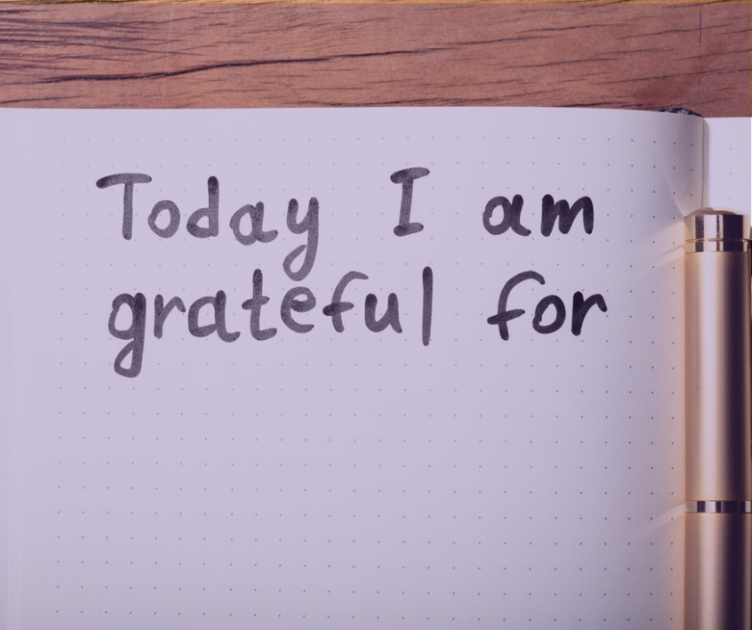
11/18 | Did you know that expressing gratitude can strengthen relationships and build emotional resilience?  Take a moment today to send a quick thank-you text or note to someone who’s made a difference in your life. A little appreciation goes a long way!  #GratitudeWeek #DuPagePLT | 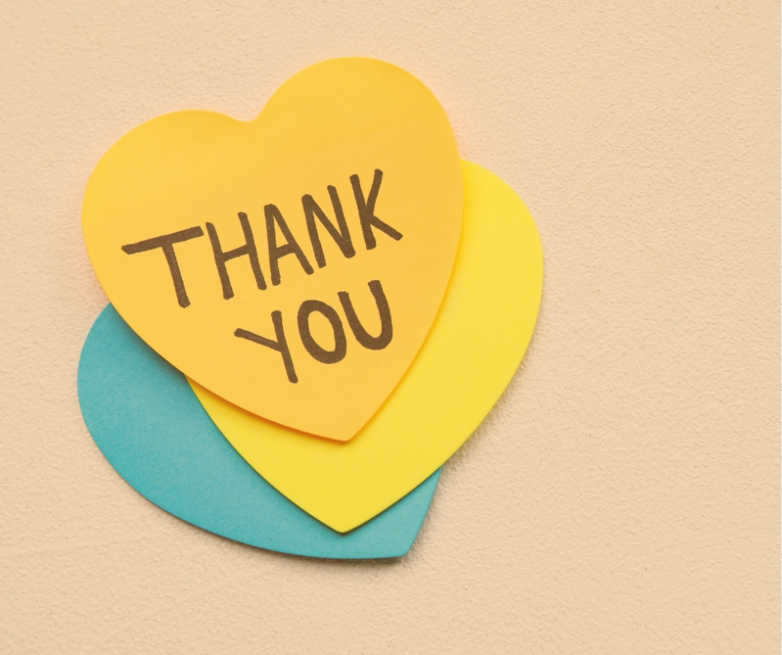
11/19 | Practicing gratitude isn’t just good manners—it’s good for your brain! Studies show that people who regularly reflect on what they’re thankful for experience less anxiety and more positive emotions.  Pause today and share one thing you’re grateful for in the comments below!  #GratitudeWeek #DuPagePLT | 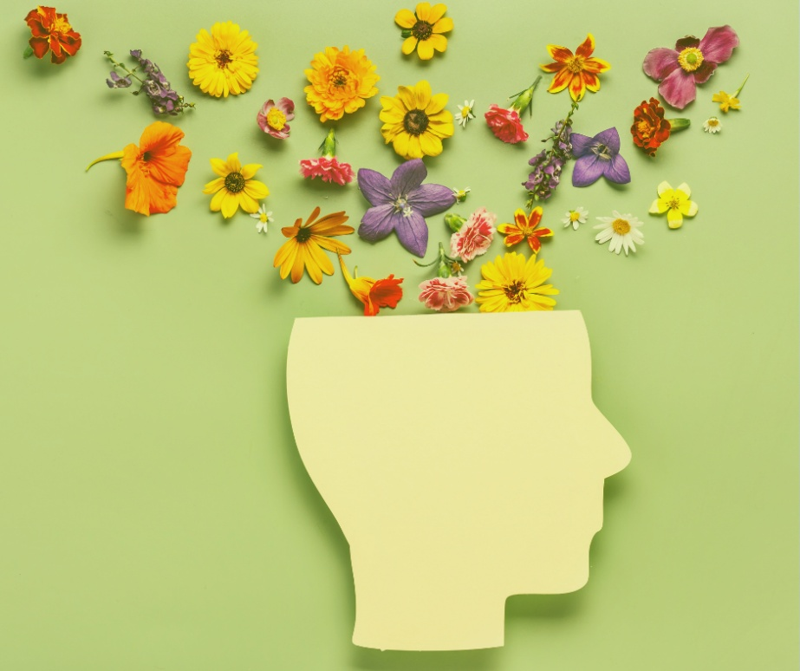
11/20 | Families who share gratitude together build stronger bonds and happier homes. At dinner tonight, go around the table and have each person name one thing they’re thankful for.  #GratitudeWeek #DuPagePLT | 
11/21 | As Gratitude Week wraps up, remember—thankfulness isn’t just for one week a year. Keep the momentum going by starting a gratitude jar or journaling one positive thing each day. Small acts of gratitude can create lasting happiness and health!  #GratitudeWeek #DuPagePLT | 

Instagram
11/17 | Happy Gratitude Week! Gratitude isn’t just about saying “thanks.” When you take time to appreciate what’s around you, you feel better, connect deeper, and spread more positivity.  #GratitudeWeek #LeaveYourMark #DuPagePLT | 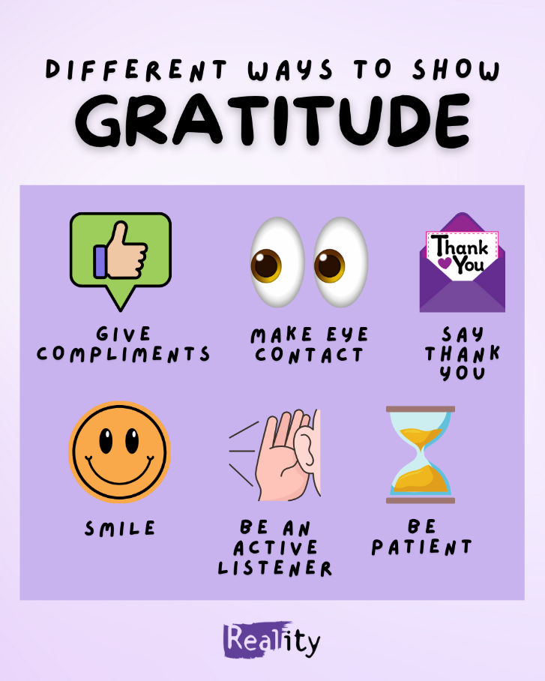
11/18 | Say it. Believe it. Feel it. Affirmations like these can help lower stress and build a more positive mindset!  #GratitudeWeek #LeaveYourMark #DuPagePLT | 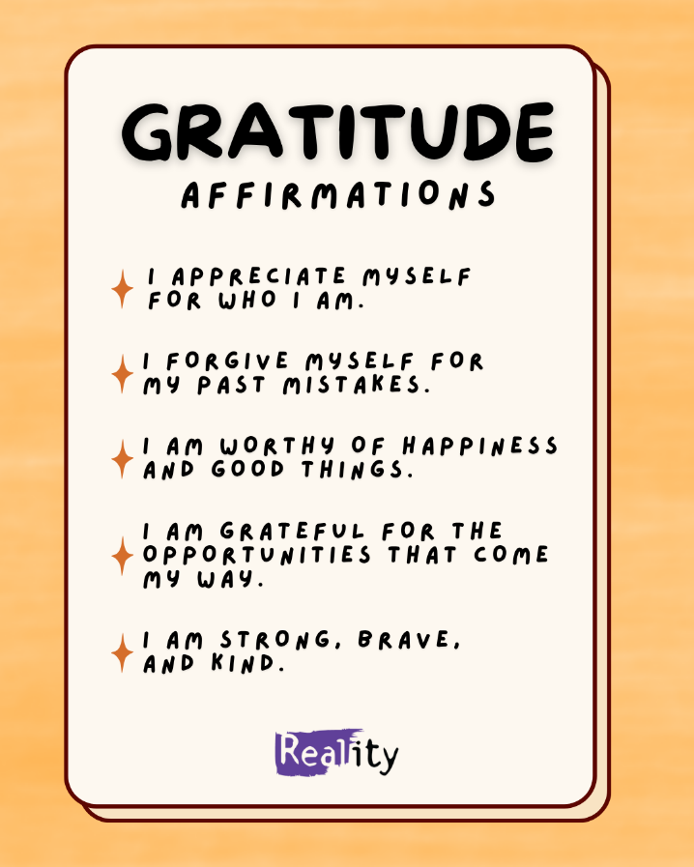
11/19 | Big or small, fill your gratitude jar with moments that make you smile! Focusing on gratitude can boost happiness and help you appreciate the little things.  #GratitudeWeek #LeaveYourMark #DuPagePLT | 
11/20 | Ready to start a gratitude journal but not sure where to begin? Try these beginner prompts. Writing down what you’re grateful for helps train your brain to focus on the positives — a simple step for better mental health!  #GratitudeWeek #LeaveYourMark #DuPagePLT | 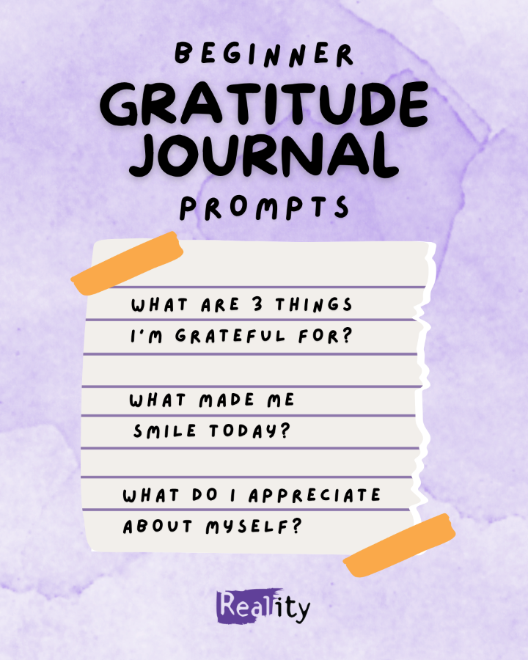
11/21 | Gratitude feels even better when you share it. As Gratitude Week wraps up, send this to someone who’s made your day brighter and let them know you’re thankful for them! A simple “thank you” can boost their mood and yours too.  #GratitudeWeek #LeaveYourMark #DuPagePLT | 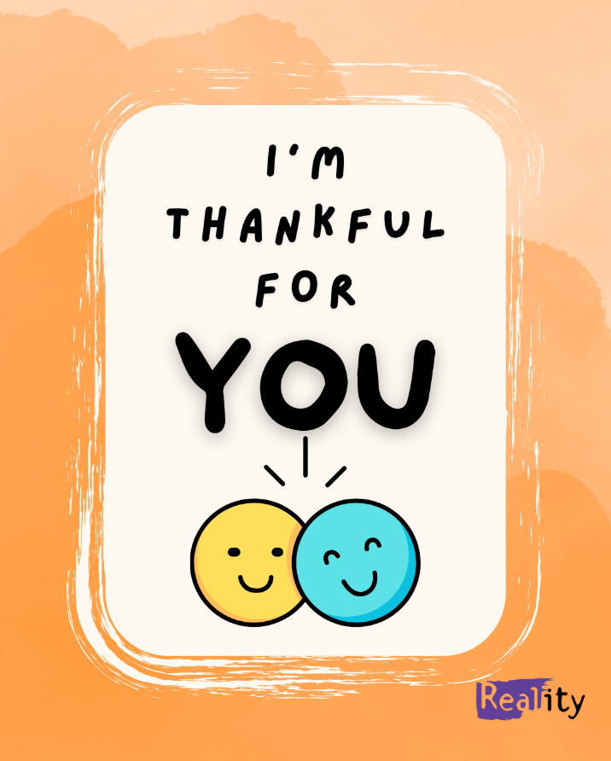

Thank you for doing your part to promote mental wellness and Gratitude Week!
Visit us at:
 www.facebook.com/DuPagePLT www.DuPagePLT.org  www.twitter.com/PLTDuPage


@leaveyourmarkdupage

